Hands-on 1:

Design Pattern and Principles :

Exercise 1 :

Implementing the Singleton Pattern :

Logger class(Singleton Class):
public class Logger {
private static Logger instance;
private Logger(){
System.out.println("Initialized");
}
public static Logger getInstance(){
if(instance==null){
instance=new Logger();
return instance;
}
return instance;
}
public void log(String message){
System.out.println("Log :"+message);
}

}

Main class :

public class Main {
public static void main(String[]args){
Logger logger1=Logger.getInstance();
logger1.log("First message");
Logger logger2=Logger.getInstance();
logger2.log("Second message");
if(logger1==logger2){
System.out.println("Both instances are same (Singleton class confirmed) ");
}else{
System.out.println("Both instances are not same (Singleton class confirmed)");
}
}
}

OUTPUT:
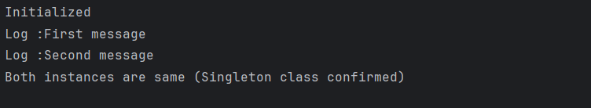

Exercise 2:
Implementing the Factory Method Pattern :
Document interface:
public interface Document {
void open();
}
WordDocument.java
public class WordDocument implements Document {
public void open() {
System.out.println("Opening Word Document");
}
}
PdfDocument.java
public class PdfDocument implements Document {
public void open() {
System.out.println("Opening PDF Document");
}
}
ExcelDocument.java
public class ExcelDocument implements Document {
public void open() {
System.out.println("Opening Excel Document");
}
}
Implementing the Factory Methods :
DocumentFactory.java
public abstract class DocumentFactory {
public abstract Document createDocument();
}
WordDocumentFactory.java
public class WordDocumentFactory extends DocumentFactory {
public Document createDocument() {
return new WordDocument();
}
}
PdfDocumentFactory.java
public class PdfDocumentFactory extends DocumentFactory {
public Document createDocument() {
return new PdfDocument();
}
}
ExcelDocumentFactory.java
public class ExcelDocumentFactory extends DocumentFactory {
public Document createDocument() {
return new ExcelDocument();
}
}
Main.java
public class Main {
public static void main(String[] args) {
DocumentFactory wordFactory = new WordDocumentFactory();
Document wordDoc = wordFactory.createDocument();
wordDoc.open();

DocumentFactory pdfFactory = new PdfDocumentFactory();
Document pdfDoc = pdfFactory.createDocument();
pdfDoc.open();

DocumentFactory excelFactory = new ExcelDocumentFactory();
Document excelDoc = excelFactory.createDocument();
excelDoc.open();
}
}

OUTPUT:
